Viskar Fab Tex Rajasthani Hand Block Printed Jaipuri Cotton Double Bedsheet with 2 pillow covers Wild Orchid Turquoise Blue
by Viskar Fab Tex
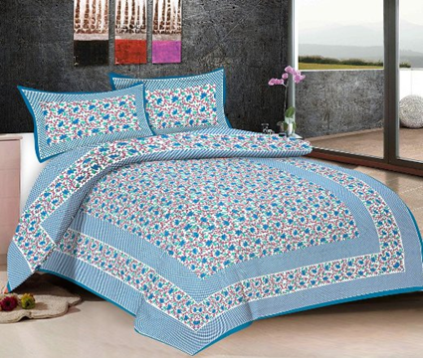

- Available from these sellers.
- 1 offer from 675.00
- 100% Cotton - Finest Quality - From a Leading Manufacturer in Jaipur
- Package Contains: One Double Bed Sheet & 2 Pillow Covers - Bed Sheet size - 225 x 245 CMS Pillow Size - 43 x 70 CMS
- *Due to different computer monitors/calibrations colors may vary slightly from the picture* - Washing Care: Mild Wash, Do not tumble dry, Do not dry clean, Do not bleach and Dry in shade.
- We use finest quality 20's cotton yarn count for our fabric. Quality materials and colours have been utilised to provide you with soothing and long lasting colours.
- *Healing colours to bring balance at your home. *Printed using traditional technique. *Decor for abstract and modern theme. *Natural Pigment Colours

Viskar Fab Tex Jaipuri Hand Block Traditional Cotton Double Bedsheet with 2 Pillow covers Ajarak Wine Red
by Viskar Fab Tex
Be the first to review this item

Available from these sellers.
1 offer from 595.00
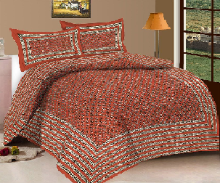
- 100% Cotton - Finest Quality - From a Leading Manufacturer in Jaipur
- Package Contains: One Double Bed Sheet With 2 Pillow Covers - Bed Sheet size - 225 x 245 CMS Pillow Size - 43 x 70 CMS
- *Due to different computer monitors/calibrations colors may vary slightly from the picture* - Washing Care: Mild Wash, Do not tumble dry, Do not dry clean, Do not bleach and Dry in shade.
- We use finest quality 20's cotton yarn count for our fabric. Quality materials and colours have been utilised to provide you with soothing and long lasting colours.
- *Healing colours to bring balance at your home. *Printed using traditional technique. *Decor for abstract and modern theme. *Natural Pigment Colours

Product Information
Technical Details
Color | Rust
Item Weight | 848 g
Shipping Weight | 890 Grams
Item Part Number | VFT1000RD191Q
Primary material | Cotton
Upholstery material | Cotton
Capacity | Double
Item Shape | Rectangular

Snoopy Heritage Jaipuri, Double Bed Sheet (2 Complimentary Pillow Cover, 250 TC, Heavy Cotton)
by Snoopy
Be the first to review this item
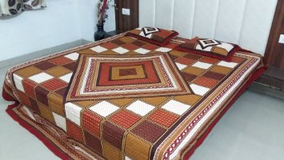

Price: | 999.00
Sale: | 599.00 + Delivery charges may apply Details
You Save: | 400.00 (40%)
 | Inclusive of all taxes
In stock.
Sold and fulfilled by KIRAN POLYFAB (4.2 out of 5 | 94 ratings).
- Jaipur Heritage Block Print
- King Size, 90 x 100 Inches
- 100% Cotton
- 250 TC, Fast Colour
- Machine Wash, Use Mild Detergent, Dry in Shade

Product Information
Technical Details
Color | Maroon,Brown, Brick Color
Item Weight | 499 g
Product Dimensions | 40 x 35 x 3 cm
Shipping Weight | 500 Grams
Item Model Number | 01SNPMRNJPR
Item Part Number | BLKMRN001
Primary material | Cotton
Upholstery material | Cotton
Capacity | King
Number of Pieces | 1
Item Shape | Rectangular

Viskar Fab Tex Jaipuri Hand Block Traditional Cotton Double Bedsheet with 2 Pillow covers Mosaic Octa Teal Blue
by Viskar Fab Tex
Be the first to review this item

Available from these sellers.
1 offer from 595.00
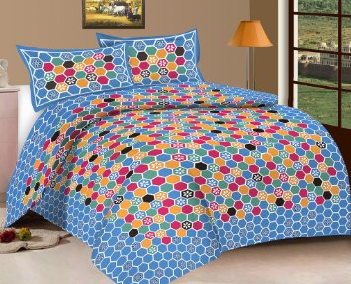
- 100% Cotton - Finest Quality - From a Leading Manufacturer in Jaipur
- Package Contains: One Double Bed Sheet With 2 Pillow Covers - Bed Sheet size - 225 x 245 CMS Pillow Size - 43 x 70 CMS
- *Due to different computer monitors/calibrations colors may vary slightly from the picture* - Washing Care: Mild Wash, Do not tumble dry, Do not dry clean, Do not bleach and Dry in shade.
- We use finest quality 20's cotton yarn count for our fabric. Quality materials and colours have been utilised to provide you with soothing and long lasting colours.
- *Healing colours to bring balance at your home. *Printed using traditional technique. *Decor for abstract and modern theme. *Natural Pigment Colours

Product Information
Technical Details
Color | Blue
Item Weight | 848 g
Shipping Weight | 890 Grams
Item Part Number | VFT1000BL188Q
Primary material | Cotton
Upholstery material | Cotton
Capacity | Double
Item Shape | Rectangular

sss

